Post-Exploitation and Data Exfiltration Report

1. Objective
The objective of this lab is to simulate a real-world post-exploitation scenario in a controlled environment. The exercise focuses on credential extraction, password cracking, lateral movement, and covert data exfiltration techniques.

2. Lab Environment
Attacker Machine: Kali Linux
Target Machine: Windows (Metasploitable3)
Tools Used: Mimikatz, Hashcat, Impacket
Network: Isolated virtual lab environment

3. Methodology
The attack chain followed a structured methodology:
1. Initial access using valid credentials
2. Privilege validation and execution context setup
3. Credential dumping from memory
4. Offline password cracking
5. Lateral movement using recovered credentials
6. Data exfiltration using DNS tunneling
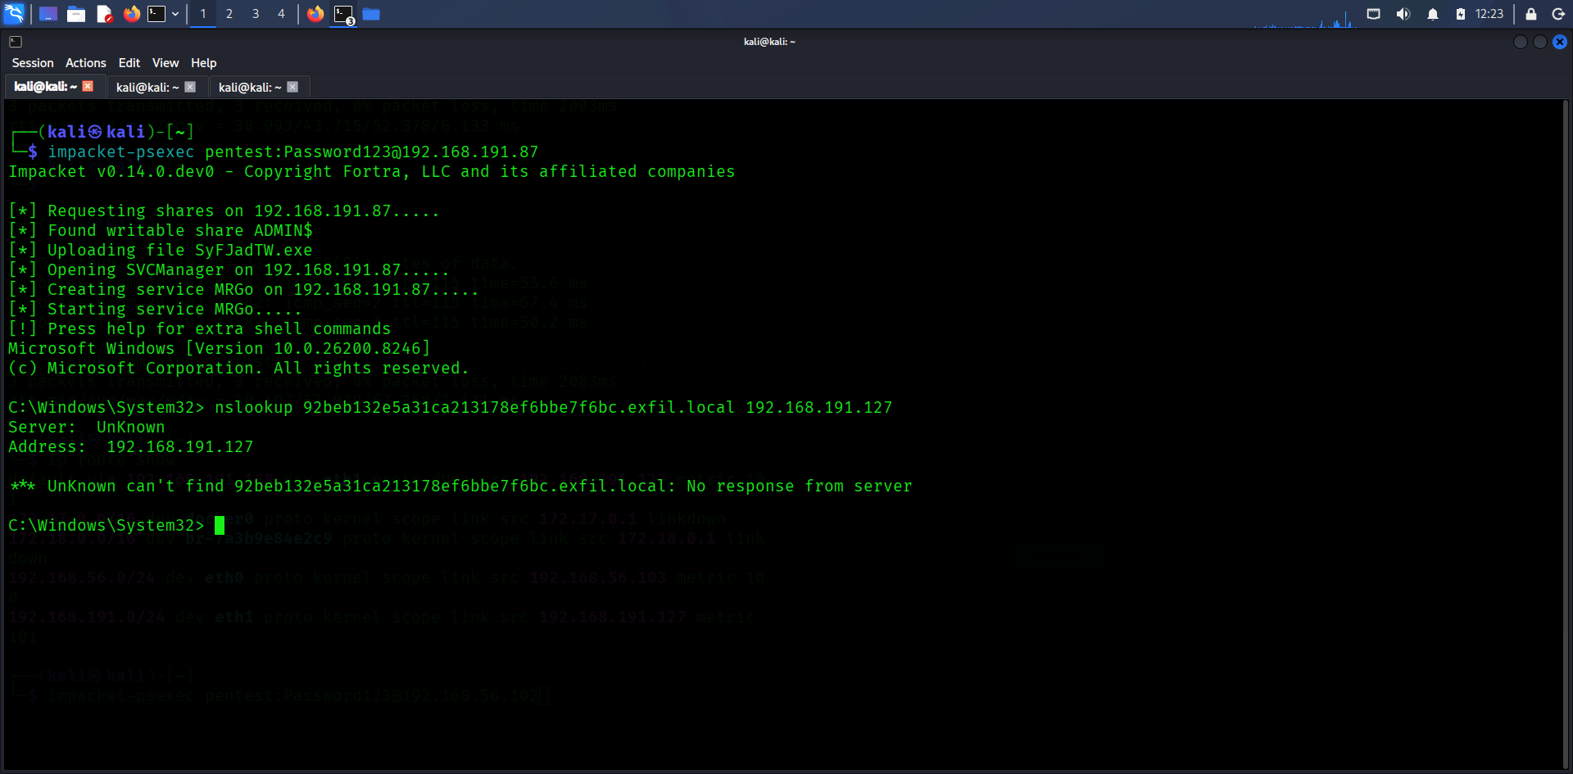

4. Credential Dumping
Credential dumping was performed to extract authentication material from memory. NTLM hashes were successfully obtained from the target system.

Hash Type | Username | Hash Value
NTLM | Administrator | 92beb132e5a31ca213178ef6bbe7f6bc
NTLM | pentest | 58a478135a93ac3bf058a5ea0e8fdb71

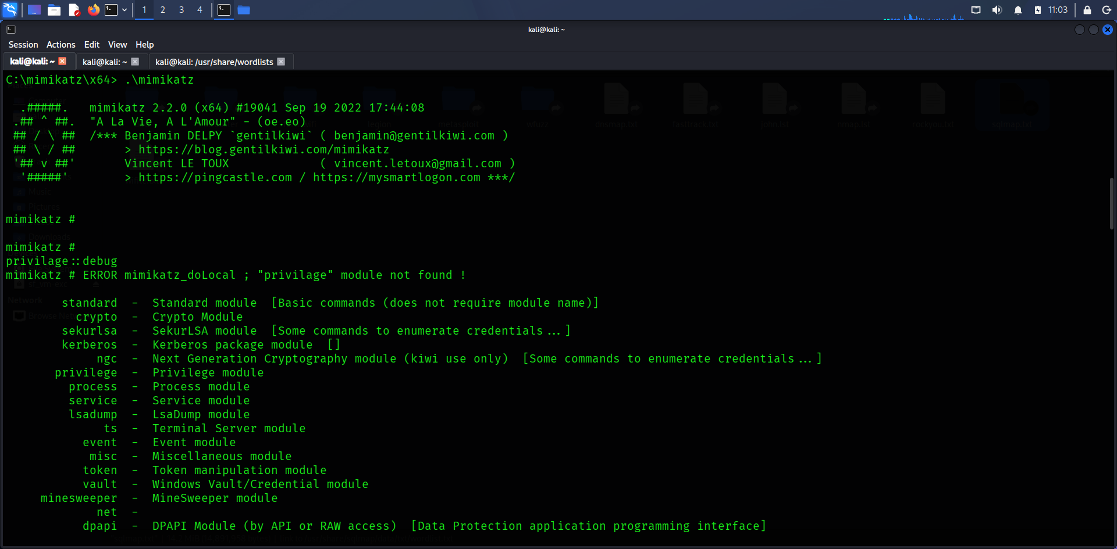
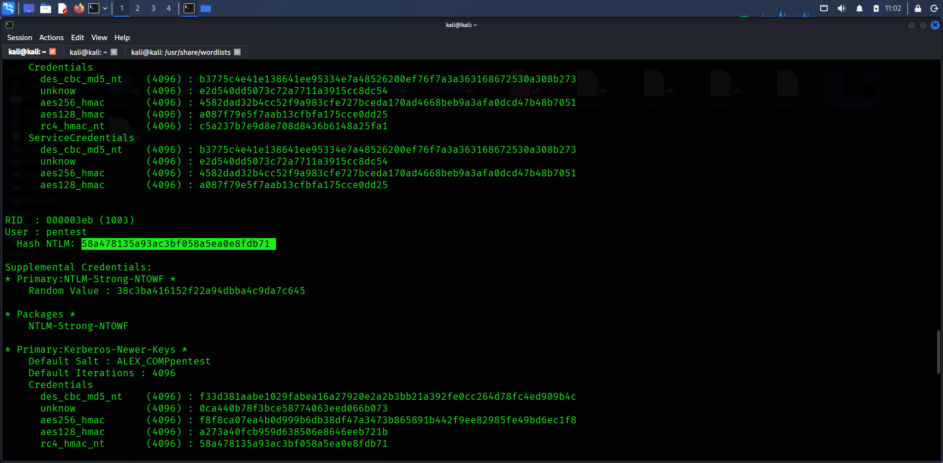

5. Password Cracking
Extracted hashes were cracked using a dictionary attack. The use of weak passwords significantly reduced cracking time.
Result: pentest → Password123

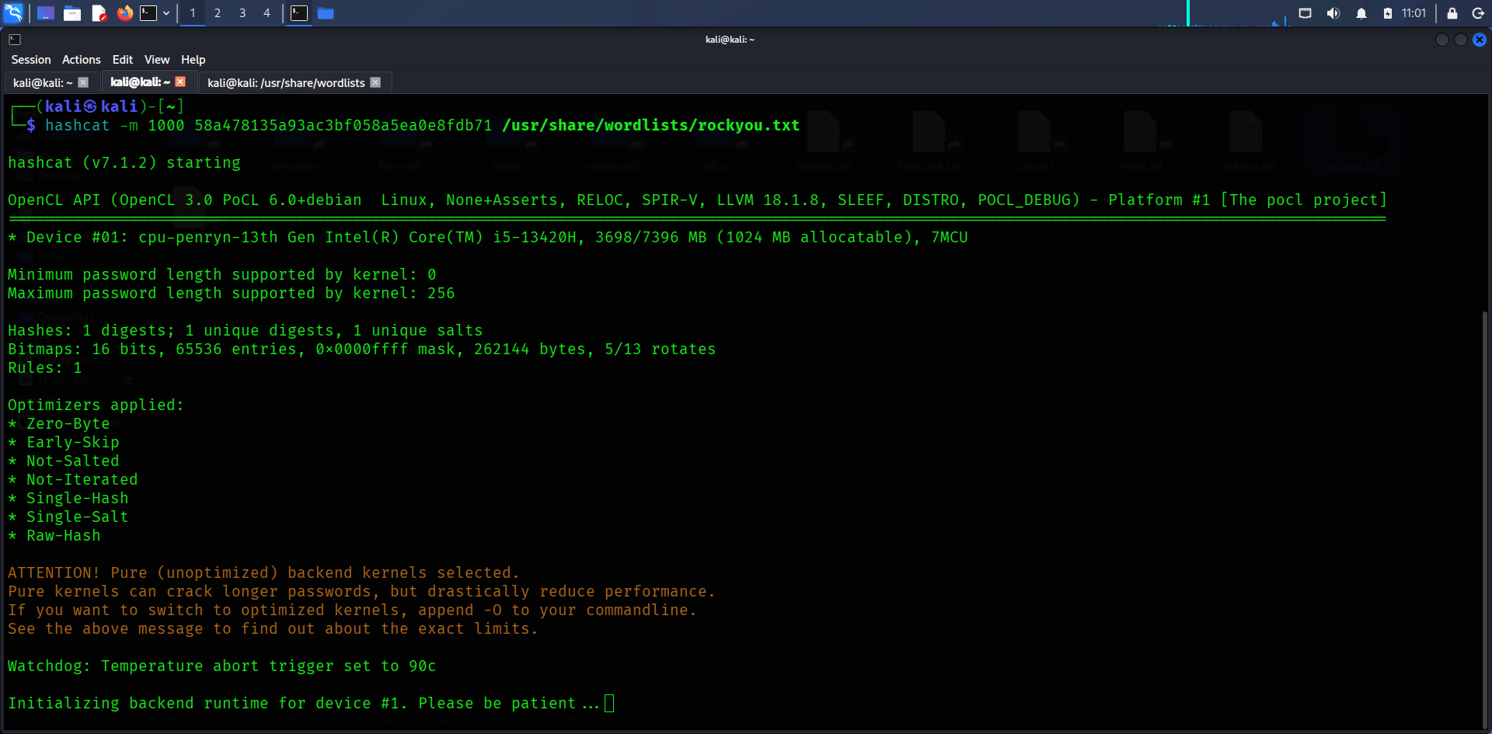

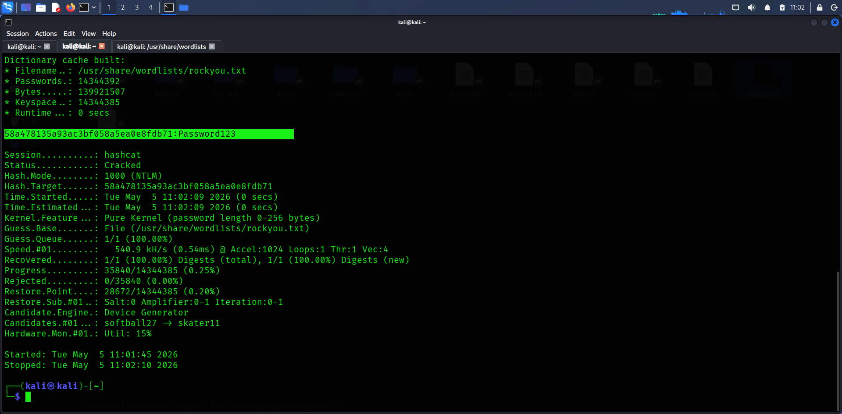

6. Data Exfiltration
Data exfiltration was simulated using DNS tunneling. Encoded data was embedded into DNS queries and transmitted to a controlled endpoint.
Example Domain Used: 92beb132e5a31ca213178ef6bbe7f6bc.exfil.local
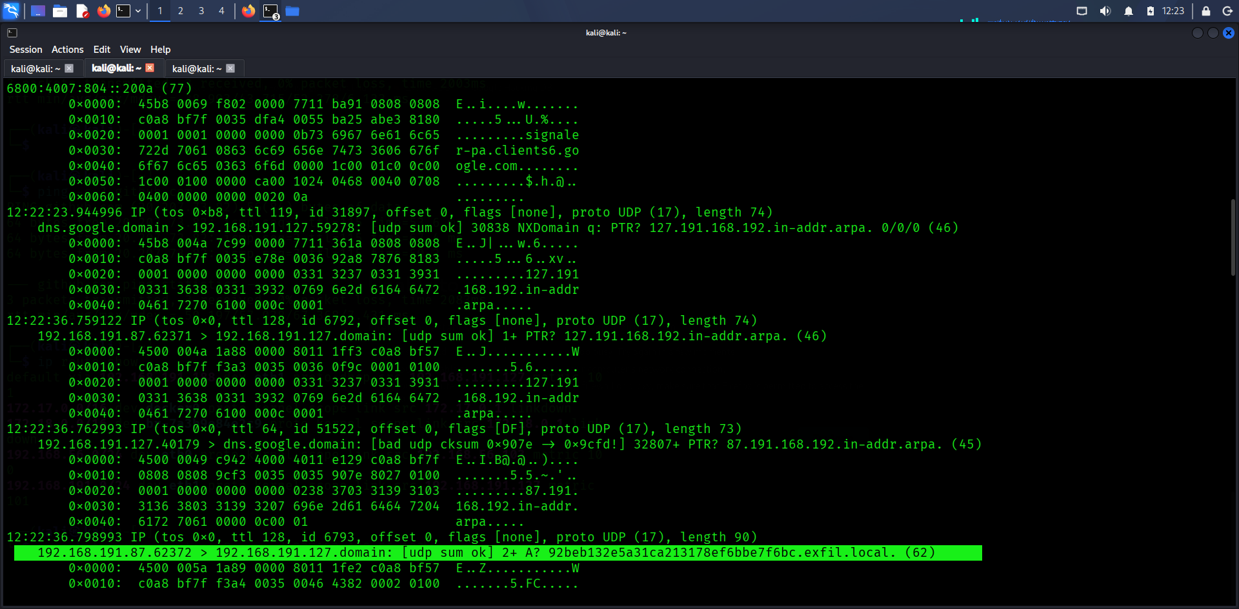

7. Analysis and Findings
- Weak passwords are easily cracked
- NTLM hashes can be reused for authentication
- Administrative tools can be abused for stealthy movement
- DNS traffic can be leveraged for covert communication

8. Conclusion

This lab successfully demonstrated a full attack lifecycle from credential access to data exfiltration. It highlights the importance of strong defenses, monitoring, and secure credential management.

